http://learning.blogs.nytimes.com/2014/09/17/the-isis-threat-teaching-about-the-complex-war-raging-in-iraq-and-syria/?_r=0

The ISIS Threat
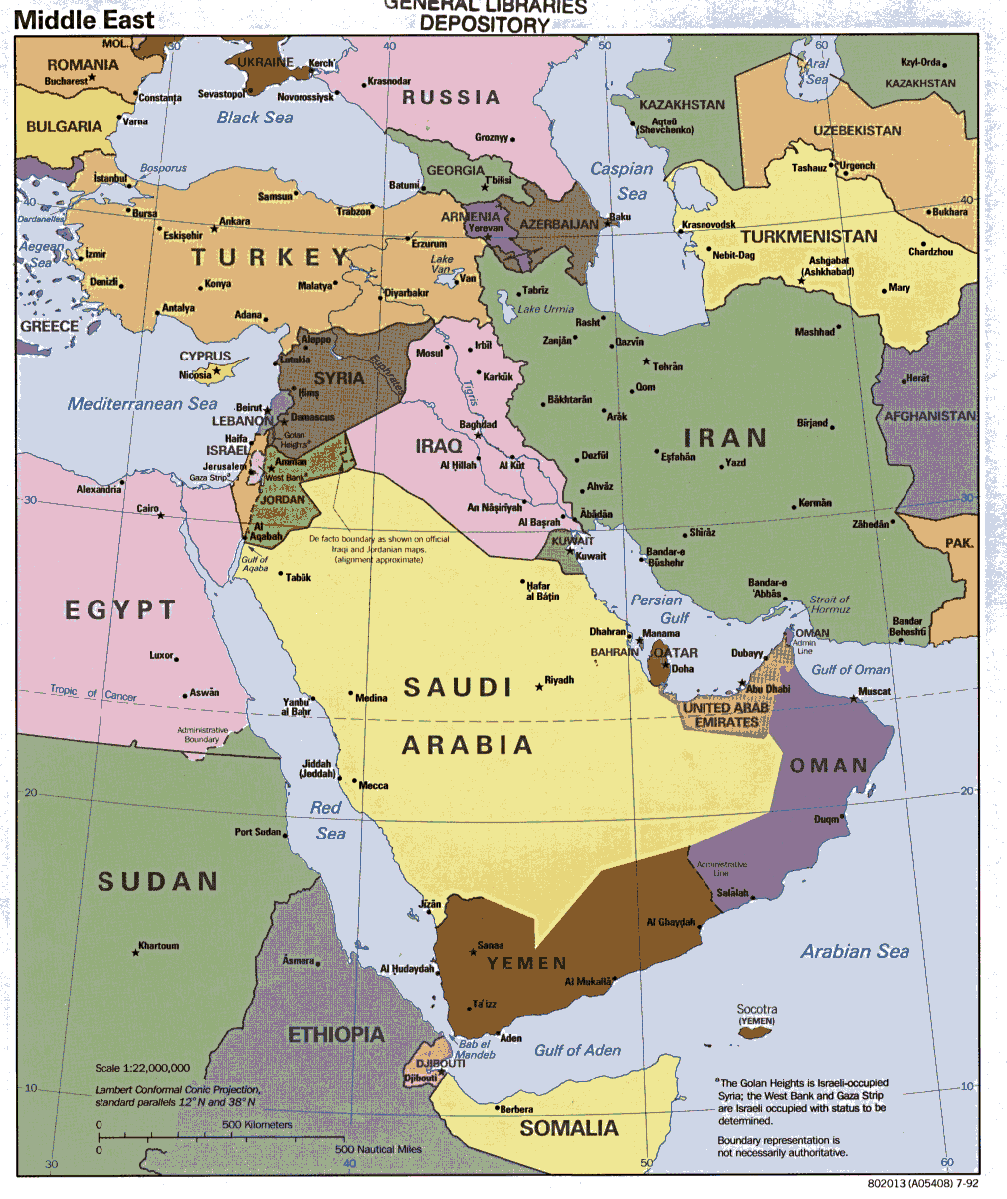

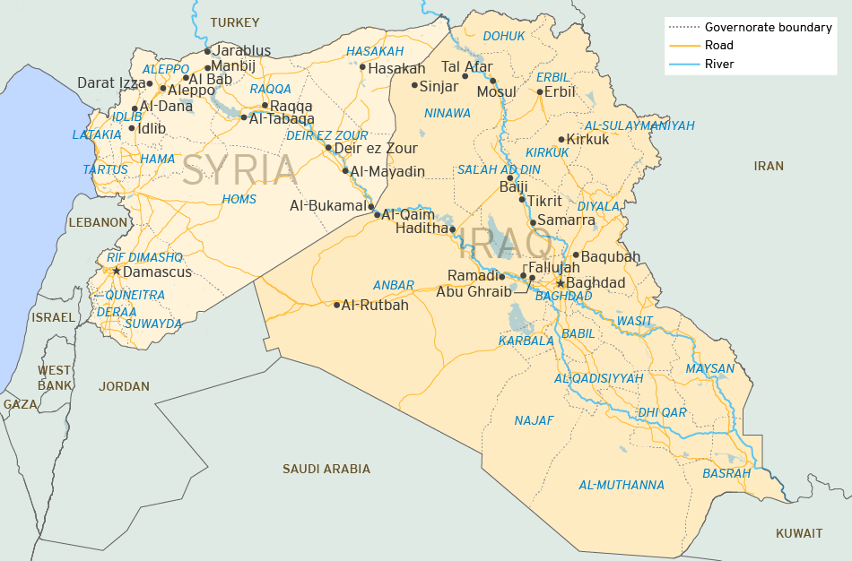

- In pairs analyze the maps, graphs, charts and images in:
- http://www.nytimes.com/interactive/2014/09/16/world/middleeast/how-isis-works.html
- http://www.nytimes.com/interactive/2014/06/12/world/middleeast/the-iraq-isis-conflict-in-maps-photos-and-video.html#caliphate-map
- http://www.nytimes.com/interactive/2014/06/12/world/middleeast/the-iraq-isis-conflict-in-maps-photos-and-video.html#refugee-origins
- http://www.nytimes.com/interactive/2014/06/12/world/middleeast/the-iraq-isis-conflict-in-maps-photos-and-video.html#attacks

You are to analyze, take notes and then report back to the class on one of the panels of information: Organization, Territory, Financing, Governing, Military, Weapons, Geographic Goals, Refugees and Attacks.

- Should the United States and other countries use military action to try to eliminate ISIS? Explain.

